- Main page

  - Table of content

    - EUR-Lex metadata fields classification – top level

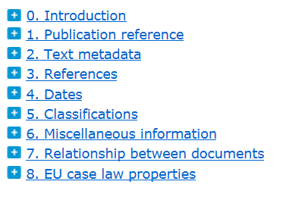
Table of content shall provide easy access to the legal analysis. By default, only the top level shall be displayed (metadata classification).

It shall be collapsed by default. Expand all / Collapse all function and search in the table of content shall be available.

When clicking on , the next sublevel shall be displayed in the table of content. There are four levels expected (top level plus three sublevels).

When clicking on the label, the relvant part of the legal analysis methodology shall be displayed in the main part of the screen.

The table of content shall work in colaboration with the main part of the screen (results list). If there is a search in the egal analysis methodology done and the user display the text of an EUR-Lex field from the results list, the same subpart should be also expanded in the table of content.

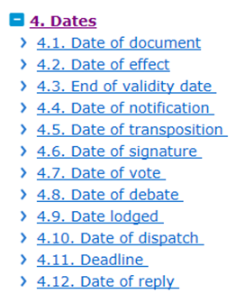

TODO:
- Celex numbers should be integrated here as a specific item.
- EuroVoc methodology should be also added
- Publication reference provides only info about relevant cdm properties, I do not know if any other information makes sense (probably only some examples for OJ, Recueil – paper version and electronic).
- EU case law properties should be renamed to Case law properties.
- National case law and JURE properties should be also added.
- What about lawmaking procedures and case law entity properties?

The table of content shall provide a desirable view: Before accessing the first sublevel from the table of content (by clicking on or on "Expand all" or by using the search box), the user shall be able to indicate whethear it should contain EUR-Lex fields or cdm properties.

This concerns only the first sublevel; all other sublevels provide similarly as the top level only one common view.

      - First sublevel: EUR-Lex fields

This shall be by default option. The first sublevel contains list of relevant EUR-Lex fields (label followed by abbreviation):

      - First sublevel: cdm super-properties

Alternatively and when requested by the user, the first sublevel provides list of cdm super-properties representing relevant EUR-Lex fields:

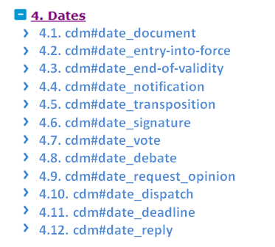

Note: To achieve such view and certain level of automatization by implementing of the cdm updates, cdm properties should contain the following annotations:

Relevant for legal analysis (exists)
Legal analysis classification (dates, classification, miscellaneous information, relations between documents – MS,…) (if not available, such mapping must be done manually by us, following cdm updates)

  - Access to templates

This shall offer access to templates of documents which are relevant for the legal analysis and prepared by us or our contractor.

Templates provide information about the metadata fields to be created, if possible also by providing relevant values.

They can be currently found in the Legal analysis methodology – Treatment of specific documents (part 9), in the mapping table and in the methodology for EuroVoc.

Access to templates shall be collapsed by default. Expand all / Collapse all function and search in the table of content shall be available.

When clicking on , the next sublevel shall be displayed in the table of content. There are two levels expected.

When clicking on the label, the templates relvant for this entry will be displayed in the form of titles in the main part of the screen.

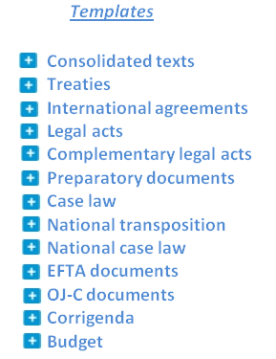

  - Search on the main page

This shall provide a text search in the legal analysis methodology or a text search and/or filtering (selection of values in drop-down menus) in the templates.

    - Text search in the legal analysis methodology

This text search coveres whole text of the legal analysis methodology (which is also covered by the Table of content described in …), except of templates.

One peace of text covers the complete text of the methodology related to one EUR-Lex field.

User can insert one or several terms. Terms shall be autonatically contected by AND operator.

The search shall shall run after clicking on  or by enter key.

    - Results list for text search in the legal analysis methodology

On the results list, all parts of the text containing highlighted keyword(s) entered by the user are displayed together with the active references to the EUR-Lex field (first subdivision) and the closed subpart. The text displayed shall cover complete sentences containing the keyword(s) or keyword(s) plus 5 terms before and after.

The complete text of the first subdivision or of the subpart will be displayed after clicking on one of the references. The keywords stay highlighted. The table of content will automatically change; the relevant subpart will be expanded.

It shall be possible to go back to the results list.

Facety:

Ak si vyhladam date of signature v metodologii, vo facetoch sa mi objavi relevant for:
Dts (1, 2, 3)
Dtt (iba pre sector 2 – A a 3 – R, L, D)
Resource type (agreement, treaty,…)
Author (commission, …)
annotation

EuroVoc (international agreement, …)
Subject matter
Directory eu legislation

Ked kliknem na R, zobrazi sa mi:

List templates ktore obsahuju SG=yes AND DTT=R
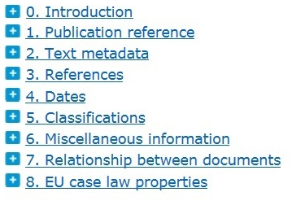

4. Dates
4.1. cdm#date_document
4.2. cdm#date_entry-into-force
4.3. cdm#date_end-of-validity
4.4. cdm#date_notification
4.5. cdm#date_transposition
4.6. cdm#date_signature
4.7. cdm#date_vote
4.8. cdm#date_debate
4.9. cdm#date_request_opinion
4.10. cdm#date_dispatch
4.11. cdm#date_deadline
4.12. cdm#date_reply

Templates

Consolidated texts
Treaties
International agreements
Legal acts
Complementary legal acts
Preparatory documents
Case law
National transposition
National case law
EFTA documents
OJ-C documents
Corrigenda
Budget

LAM Templates Results 1 2 3 4 5 6

See also: External Links: Common Metadata Model

Relevant metadata:

Eurovoc

Proportional representation
JOINT_PROP_DIR

Identifier: http://eurovoc.europa.eu/3383

Start use: yyyy-mm-dd
Date of creation: yyyy-mm-dd

Decription: Proposal for a directive adopted jointly
by the High Representative of the Union
for Foreign Affairs and Security Policy and
the Commission

Scope note: Electoral system in which each party
is represented in proportion to the numerical
strength of the vote it receives.

Non-preferred terms:

Related terms: electoral quota

Provenance: TFEU

Parent:
Child:

EuroVoc Named Authority Lists (NAL)

Sector (DTS)
5

Type (DTN)
XG
DC
TA

Resource type
Annual report
Joint report

Author
Council
Commission
EEAS

EuroVoc
arms trade
military equipment
cooperation policy
export monitoring
export (EU)
financial management
general budget (EU)
closing of accounts
audit
implementation of the budget FACETS

User´s corner
Notifications
Propose changes

Editor´s corner Sign-in
Add new template
Add new entry in LAM

Directory code (Case Law)

Subject matter resource-type

EuroVoc Sector (DTS) Type (DTN)
label (EN)
code
Resource type (FM)

Templates Titles Celex sector Celex type Form Author EuroVoc

Search: LAM text ∼ date of effect

Annual report joint proposal directive

  - Date of effect (IF)
→ 4. Dates

The date of effect is also used as an indicator for the production (…)
→ 4. Dates → 4.2. Date of effect → 4.2.1. Definition

The date of effect must be followed by an annotation specifying the nature of the date (…)
→ 4. Dates → 4.2. Date of effect→ 4.2.3. Annotations

The date of effect is not indicated in the act, it is linked to the date of notification (…)
→ 4. Dates → 4.4. Date of notification→ 4.4.5. Analytical methodology

Sixteenth Annual Report according to Article 8(2) of Council Common Position 2008/944/CFSP defining common rules governing control of exports of military technology and equipment
→ Templates → Preparatory documents → Resource type = Annual report

Keywords:

Council
Annual Report
Article 8(2) of Council Common Position 2008/944/CFSP
control of exports of military technology and equipment

JOINT REPORT TO THE EUROPEAN PARLIAMENT AND THE COUNCIL Macao Special Administrative Region: 2014 Annual Report
/* JOIN/2015/0013 final */

→ Templates → Preparatory documents → Resource type = Joint report

Keywords:

Joint report to the European Parliament and the Council
JOIN number

Annual report of the Court of Auditors on the implementation of the budget concerning the financial year 2014, together with the institutions’ replies

→ Templates → Preparatory documents → Resource type = Joint report

Keywords:

Court of Auditors
Annual report on the EU general budget

Sixteenth Annual Report according to Article 8(2) of Council Common Position 2008/944/CFSP defining common rules governing control of exports of military technology and equipment |  |  |  |  |  |  | Edit
→ Templates → Preparatory documents → Resource type = Annual report |  |  |  |  |  |  | Edit
Seizième rapport annuel établi en application de l’article 8, paragraphe 2, de la position commune 2008/944/PESC du Conseil définissant des règles communes régissant le contrôle des exportations de technologie et d’équipements militaires |  |  |  |  |  |  | Edit
Keywords |  |  | Council  Annual Report  Article 8(2) of Council Common Position 2008/944/CFSP  control of exports of military technology and equipment |  |  |  | Edit
Comment |  |  | Does not contain COM / JOIN / SWD / SEC number |  |  |  | Edit
Celex |  |  |  |  |  |  | + Add
DTS  cdm#resource_legal_id_sector  DTT  cdm#resource_legal_type |  |  | 5  XG | Celex sector 5: Council of the EU |  |  | Edit
Dates |  |  |  |  |  |  | + Add
Date of document (DD)  cdm#work_date_document |  |  |  | yes |  |  | Edit
annotation  annot:comment_on_date |  |  |  | Date of publication |  |  | Edit
Date of dispatch (DH)  cdm#resource_legal_date_dispatch |  |  |  | yes |  |  | Edit
annotation  annot:comment_on_date |  |  |  | forwarded to the Council  forwarded to the EP |  |  | Edit
Classification |  |  |  |  |  |  | + Add
EuroVoc (DC)  cdm#work_is_about_concept_eurovoc |  |  |  | arms trade  military equipment  cooperation policy  export monitoring  export (EU) |  |  | Edit
Subject matter (CT)  cdm#resource_legal_is_about_subject-matter |  |  |  | Common foreign and security policy |  |  | Edit
Directory Code  cdm#resource_legal_is_about_concept  _directory-code |  |  |  | 11.60.30.30 External relations / Commercial policy / Trade arrangements / Common export arrangements  18.00.00.00 Common Foreign and Security Policy |  |  | Edit
Miscellaneous information |  |  |  |  |  |  | + Add
Author (AU)  cdm#work_created_by_agent |  |  |  | CONSIL  Comment: |  |  | Edit
Type of act (FM)  cdm#work_has_resource-type |  |  |  | REPORT_ANNUAL  Comment: |  |  | Edit
In force indicator  cdm#resource_legal_in-force |  |  |  | no
REP  cdm#resource_legal_repertoire |  |  |  | no
Relationships |  |  |  |  |  |  | + Add
Treaty  cdm#resource_legal_based_on_concept_treaty |  |  |  | TFEU |  |  | Edit
Legal basis  cdm#resource_legal_based_on_resource_legal |  |  |  | 32008E0944 - A08P2 |  |  | Edit
Instruments cited  cdm#work_cites_work |  |  |  | Applicable if a reference to a specific act or article of the treaty is mentioned  Citations in annex are excluded. |  |  | Edit
annotation  annot:fragment_citing_source |  |  |  | applicable
annotation  annot:fragment_cited_target |  |  |  | applicable
Examples |  |  |  | 52016XG0504(01)  52015XG0327(05)  52015XG0327(05)
Celex type | Documents | OJ-L |  |  | OJ-C | EUR-Lex |  |  | Comment
5*XG | Other documents of the Council or the Member States | 52013XG1109(01): Notice concerning the entry into force of the Treaty of Accession between the …  Currently, there are only 2 cases in the database published in OJ L. The CELEX was based on the publication date or on the internal number. |  |  | 52014XG1205(01): Conclusions of the Council and of the Representatives of the Governments of the Member States, meeting within the Council, on sport as a driver of innovation and economic growth
5*XG | Other documents of the Council or the Member States | Date of publication |  |  | Date of publication

Metadata present
In this template:

Celex
DTS
DTT
Dates
Date of document (DD)
Date of dispatch (DH)
Classification
EuroVoc (DC)
Subject matter (CT)
Directory code (CC)
Miscellaneous information
Author (AU)
Type of act (FM)
Relationships
Treaty (TT)
Legal Basis (LB)
Instrument cited (CI)

Latest news

2019-01-22 Update: Legal analysis methodology – Date of effect (IF) – Comment
See more

2019-01-22 New template: Templates – Legal acts – Decision
See more

2019-01-22 Update: Templates – OJ-C documents - Notice
See more

